# Communication protocol between server and client ‘

This project uses unity 5.x’s networking system, to make both server and clients. Since the game is not meant to use a dedicated server, one of the clients acts as host, having both the server and a local client.  
Other clients joining the hosts’ game, will be considered as remote clients.

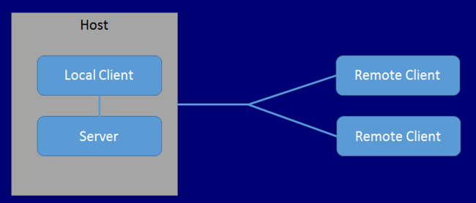

Figure 1 source: <http://docs.unity3d.com/Manual/UNetConcepts.html>

The program performs actions over the network using two methods: one that is called on the server and then runs on the clients, and the other which is called on the client and is run on the server.

### ClientRpc

Represents the methods called on the server but run on the clients. These methods are used to insure the same methods are run on all clients, and they are seeing the same game board.

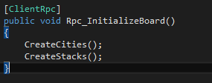

### Command

Command methods are a way for the clients to call methods to be run on the server. Since clients cannot directly run methods on each other, they use command methods, to run methods on the server, that can call rpc methods.

